**Question1**

1. Software quality attributes:

* **Availability** - CBB online ERP system should work as required and available 24 hours 7 days to all sellers and buyers. Hence, backup servers should be prepared in the case of system failure.
* **Secure** - CBB online ERP system is protected against errors, attacks and loss of valuable data, all private information such as personal and card information must be protected from any third parties.
* **Functional** - CBB online ERP system will perform the functions that it is required to on a real time basis such as allow local store sellers to manage product upload, order management, delivery tracking, generate finance report, etc.

1. Suitable software process model : **Incremental model**. Incremental model is a software process model that will deliver the core function at the first version and continue to develop the supplementary function in the next increment version.

**Justification:**

* The user requirements for this system are clearly defined.
* This project will be implemented as 2 versions, the first release will be delivered within 1.5 months and subsequent release will be planned within 1 - 2 months.
* The first release of the system will need to developed within a short period of time which is 1.5 months and there are sufficient budget
* Incremental model is particularly useful when staff is unavailable in which this project will be only handled by 4 senior engineers without recruiting additional software engineers as required by the management.

1. Methods:

* **Object oriented and analysis design (OOAD) methodology** will be appropriate for developing the CBB online ERP system.
* To illustrate, we can use UML *(Unified Modeling language)* to visualize the system that is independent from the implementation platform and language
* Thus, it could be developed on component-based which is more focus on integrating the components rather than build them from scratch and improve reusability, reduce cost of the system development

2 Tools:

* **Data modeling tools**. E.g SQL DBMS to store and manage the data such as payment, product, order, etc
* **Web development tool** E.g Visio studio to write and edit the code for CBB online ERP system

**Question 2**

1. *Gantt Chart*

| **Activity** | **Duration (Month)** | **Predecessor** | **Overlap** |
| --- | --- | --- | --- |
| D1 Cycle 4 | 1 1/4 | C1 | 1/4 |
| D2 Analysis & Design | 1/4 | D1 | 1/4 |
| D3 Coding & Testing | 3/4 | D2 | - |
| D4 Deployment & Training | 1/2 | D3 | 1/4 |

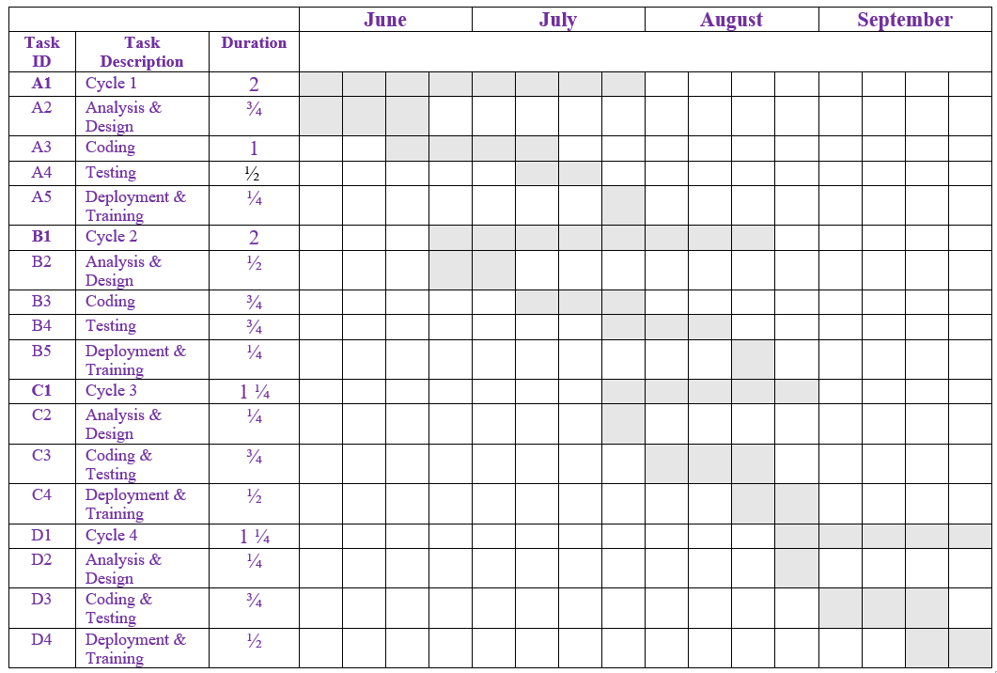

**Testing techniques:**

* **Black Box testing.** It is a testing technique in which the system functionality will be tested without knowing the internal code implementation and mostly determined by studying the system input as well as the output.

**Test case:**

| Program name: CBB online ERP system  Test date: - | | | | | |
| --- | --- | --- | --- | --- | --- |
| No. | Test case | Test data | Expected Result | Actual Results | Remarks |
| 1 | To test the edit product information function from China supplier website | Product information | The product information should be updated successfully | - | - |

**Testing techniques:**

* **Stress testing.** It is a testing technique that tests the reliability of the system to ensure it can support the intended load by stressing the system (i.e inserting many order request records).

**Test case:**

| Program name: CBB online ERP system  Test date: - | | | | | |
| --- | --- | --- | --- | --- | --- |
| No. | Test case | Test data | Expected Result | Actual Results | Remarks |
| 2 | To test the accessibility of the system when it is fully loaded with order request | Order request | The system should not get slow and still can process each of the order request within reasonable time | - | - |

1. Controlling model : Centralized control - **Manager model**

* It’s suitable model for CBB online ERP system where one sub-system act as system manager has overall responsibility for control and starts and stops other sub-system which transfer order from Malaysia buyers to China suppliers, edit the products information, calculate shipping fee automatically, process return/refund, process international shipping.

1. **Physiological** – We can provide good employment or comfortable working conditions and regular monthly salary to the software engineers such as Wi-Fi access to ease the internet connection or tea/coffee making facilities.

**Safety** – Organization should provide a stable physical and emotional environment such as a safe work environment and fair work practice to every software engineer.

**Question 3**

* + **2 Process/Organization requirements**
  + CBB online ERP system shall be confirmed to ISO 9001:2008 as practised by the existing warehouse system.
  + The new CBB online ERP system shall be continue developed using .NET platform
  + **2 external requirements**
  + A Lawyer will be assigned to consult on legislation issues such as general and special goods specification, illegal shipping, shipping charges based on different types of goods, declaration of goods, and etc.
  + An Internal consultant will be invited to join the project to handle matters regarding Privacy, Safety and Ethical issues in e-Commerce.



* **Consistency** - The CBB online ERP system interface should be consistent to avoid user confusion. Similar operations such as track products should be activated in the same way to reduce learning time.
* **User guidance** - The CBB online ERP system should provide user help facility and informative feedback if users perform invalid action or provide invalid input. For example, if the user enters an invalid product information such as price, the system should provide feedback which suggests the solution to the user so that they can solve it without getting confused.

1. **Consistency** - This aspect of requirements is to check whether there are conflicting functions occurring in the system. However, the functional requirements in CBB online ERP systems are conflicting with each other.

**Completeness** - This aspect of requirements is to check whether the system includes all necessary functions. However, there are three missing requirements where already stated in requirement analysis and elicitation stage.

**Validity** - This aspect of requirements is to check whether the functions developed meet the user requirements and whether they are confirmed needed. However, there are two requirements which should not be included in SRS as these are additional functions.

**Question 4**

* Stimuli (User click on the view product category button) -> Response (display all product records)
* Stimuli (User click on the upload button in China suppliers website) -> Response (Product pictures uploaded automatically into sellers’ Malaysia store)

1. **Periodic stimuli in CBB warehouse system**

* Every 5 seconds, check the latest product quantity and generate alert if product quantity below stock level
* Every 1 minutes, update the real storage location of the product

1. 3 factors

* **Module indencendency** - There is no proper module design and therefore the system has very high coupling and low cohesiveness.
* **Programming structure** - The structure of the CBB online ERP system need to be improved
* **Age of the program** - CBB online ERP system was developed in 1998 and has been re-engineered once in 2008 but only focuses on recovering the documentation not improving the program structure.
* Re-engineering activity - Program structure improvement as even though the system is developed in the .NET platform, the structure of the system is yet to be improved. Therefore, we can restructure the program code to improve the understanding and readability by simplifying the complex code and condition.

1. *Viewpoint Hierarchy Chart*

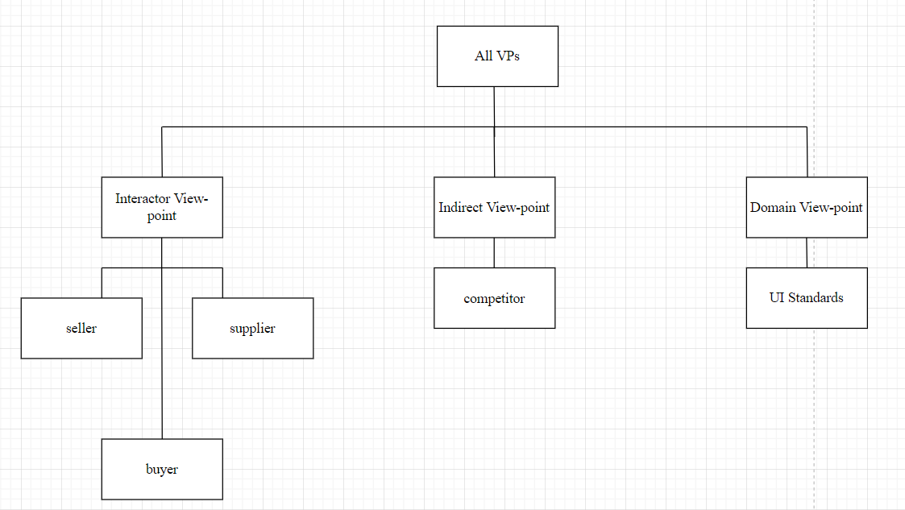

Main concern (Functional requirements) for interactor:

**Seller** - Seller can edit the product information which gets from China Supplier website.

**Supplier** - Supplier can upload the product information to the local store’s website such as product picture, name, price, description, etc

**Buyer** - Buyer can keep track of the product status (i.e shipped, delivered, received, etc)

